**CSE3506 – ESSENTIALS OF DATA ANALYTICS**

**EXPT NO: 7**

**DATE:** 24th March 2021

**NAME:** R. Harini

**REG. NO.:** 18BCE1010

**PARTITIONING BASED CLUSTERING**

**AIM**

To perform the following: 1) K-Means Clustering 2) K-medoids on US Arrests Datasets

**MATLAB PROGRAM**

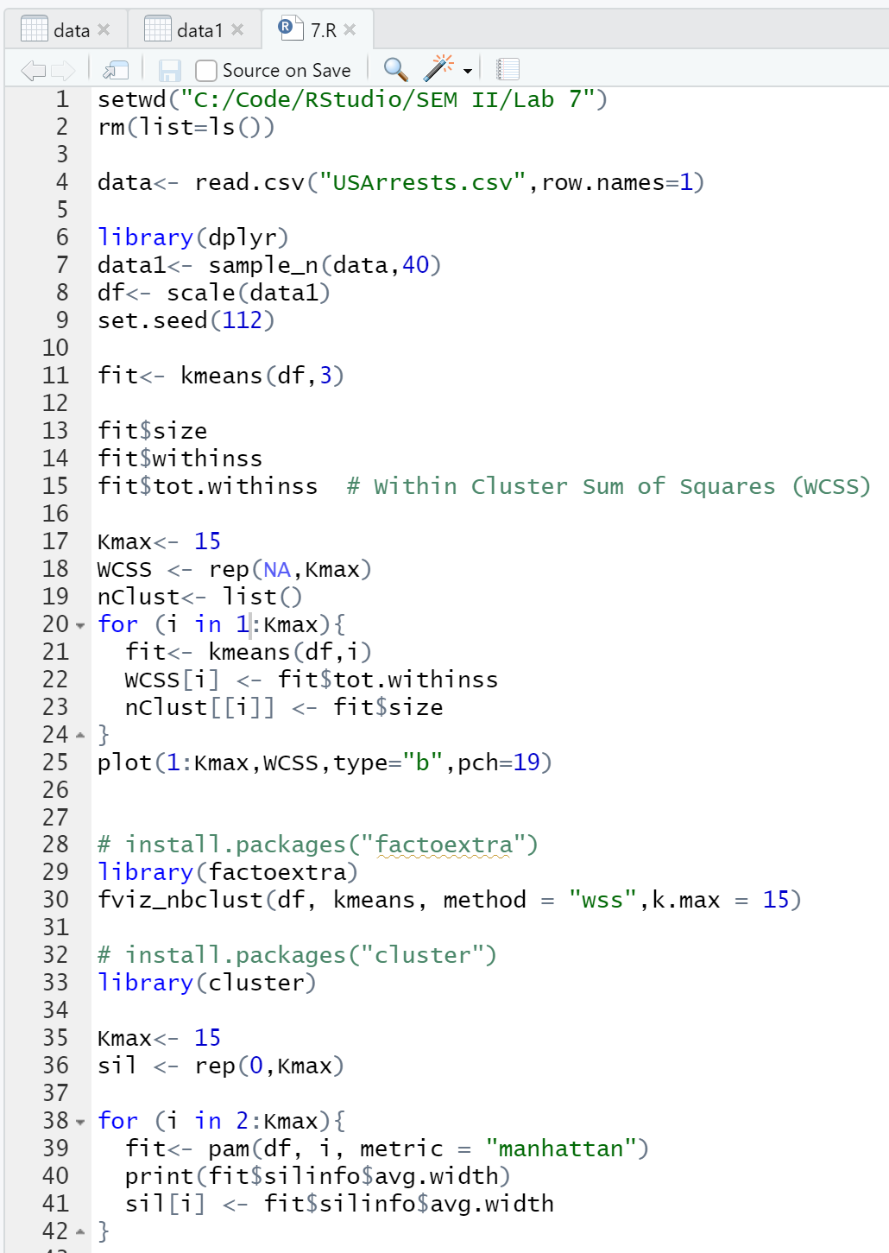

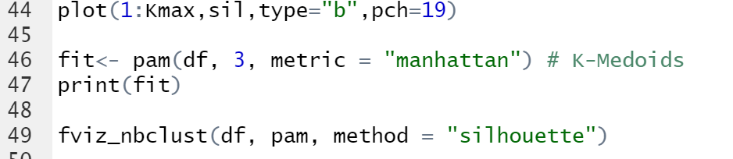

**OUTPUT**

**For Sample Size = 20**

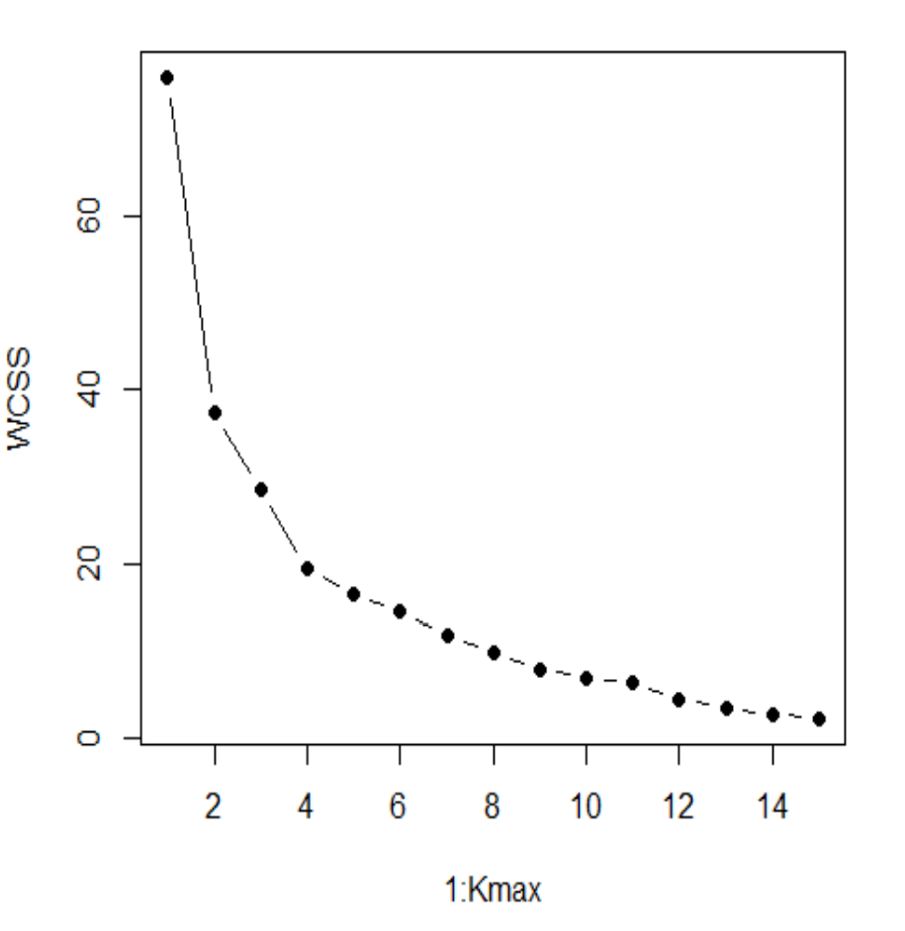

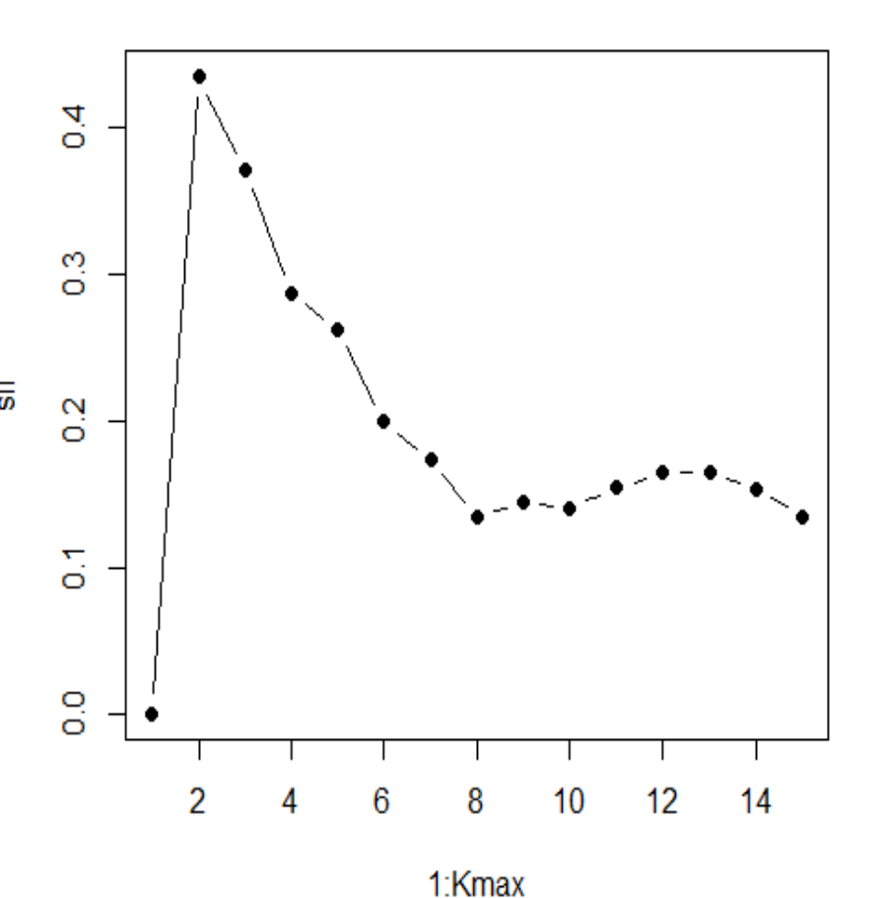

**For Sample n=30**

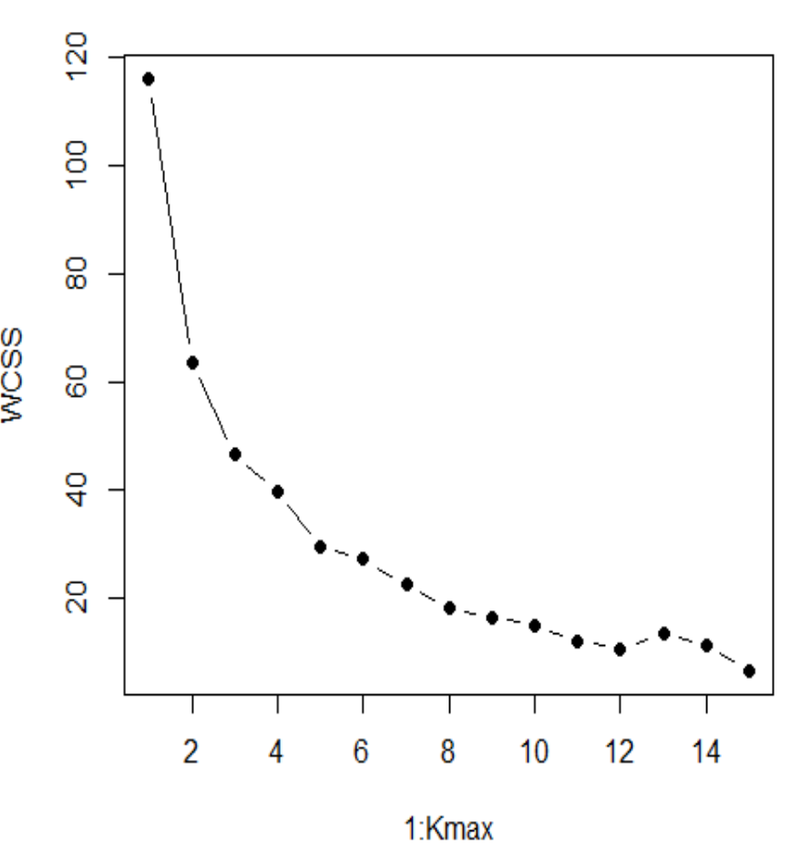

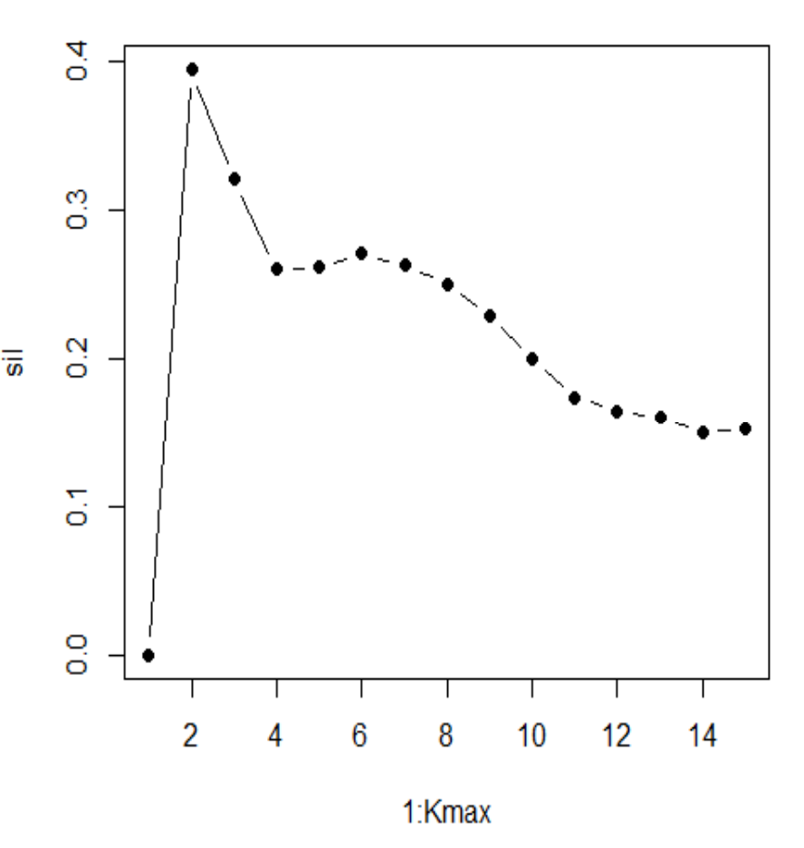

**For Sample n=40**



